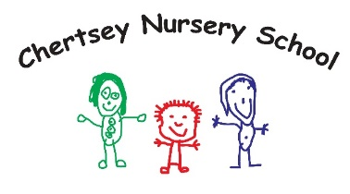
Chertsey Nursery School

Due to an increase in our numbers on role, Chertsey Nursery School has a role for Nursery Assistant working across the mainstream and specialist provision. The role will be supporting children with additional needs.

If you have a passion for working with young children and are keen to start or develop your career in one of Surrey’s four Maintained Nursery Schools, then we may have the role for you!
Some children have learning needs and therefore, excellent spoken and written English is required for all posts.

Role – 20 hours a week. Mon to Fri 11.15pm – 3.15pm

Please note – all roles are term time only and fixed term until July 2023.
Role involves working with children on a 1:1 or small group basis.

Start date: ASAP 2023
Salary: Surrey Pay Scale S1/2 FTE £19,233 pro rata

Closing date for applications: 12 noon on Friday 19th May 2023

For further details, information and application form visit our website www.chertsey.surrey.sch.uk/job-vacancies or contact Anita Cheeseman head@chertsey.surrey.sch.uk
Please specify the role or roles/hours clearly on your application

Chertsey Nursery School is committed to safeguarding and promoting the welfare of children, young people families and carers and expects all staff and volunteers to share this commitment. Appointment to this post will be subject to an enhanced check by the Disclosure and Baring Service.

